Kathmandu University

Department of Computer Science and Engineering

Dhulikhel, Kavre



Computer Graphics (COMP 342)

Mini Project Concept

Submitted to:

Mr. Dhiraj Shrestha

Department of Computer Science and Engineering

Submitted By:

Mani Dumaru

Roll no.: 15

CE-2019 3rd year/2nd semester

Submission date: 24th April, 2023

**Planetary Orbit Simulation**

For the mini project, I will try to simulate a simple two-dimensional view of an orbit of a planet in a star system. Gravitational Force attracts a lesser massive body towards the star while planets velocity tends to move it away in a straight line. They relatively form an orbit around the star in the shape of an ellipse as shown in the figure below.

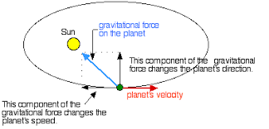

Planet’s orbit around a star

I will be using PyOpenGL library for the project and also, I may have to use PyGame whenever needed.